DEVOPS CAPSTONE PROJECT 2

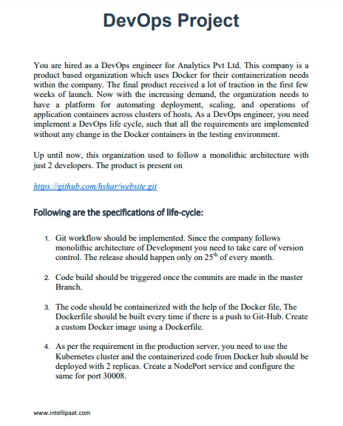

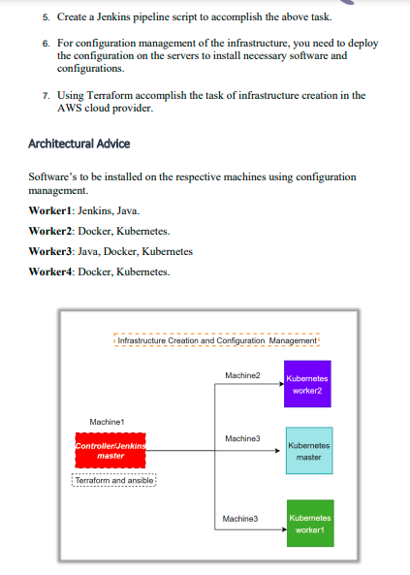

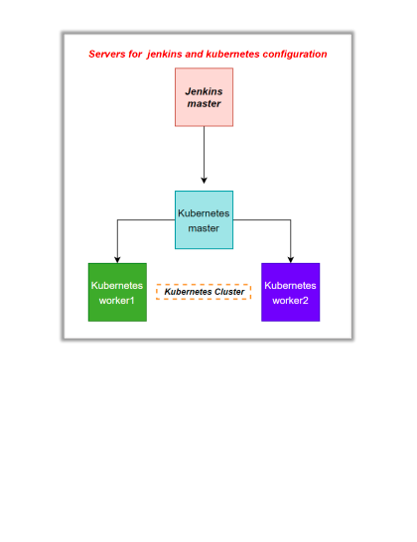

Creating 2 instances with instance_type ‘t2.medium’ in Singapore region with ubuntu OS.

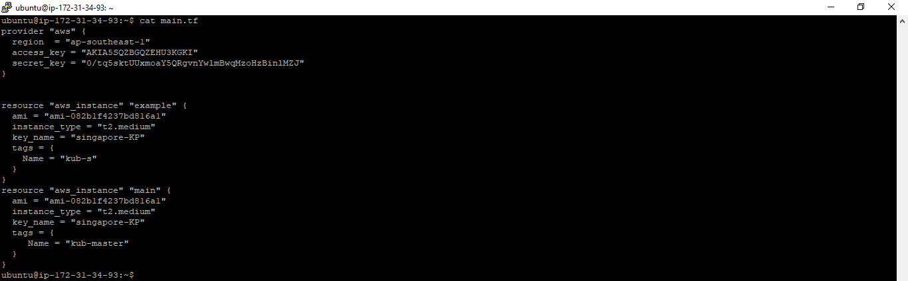

Using command ‘terraform init’ to initiate the terraform file, Later .validating the syntax of ‘main.tf’ by command ‘terraform validate’. Then we apply the architecture using ‘terraform apply’ command.

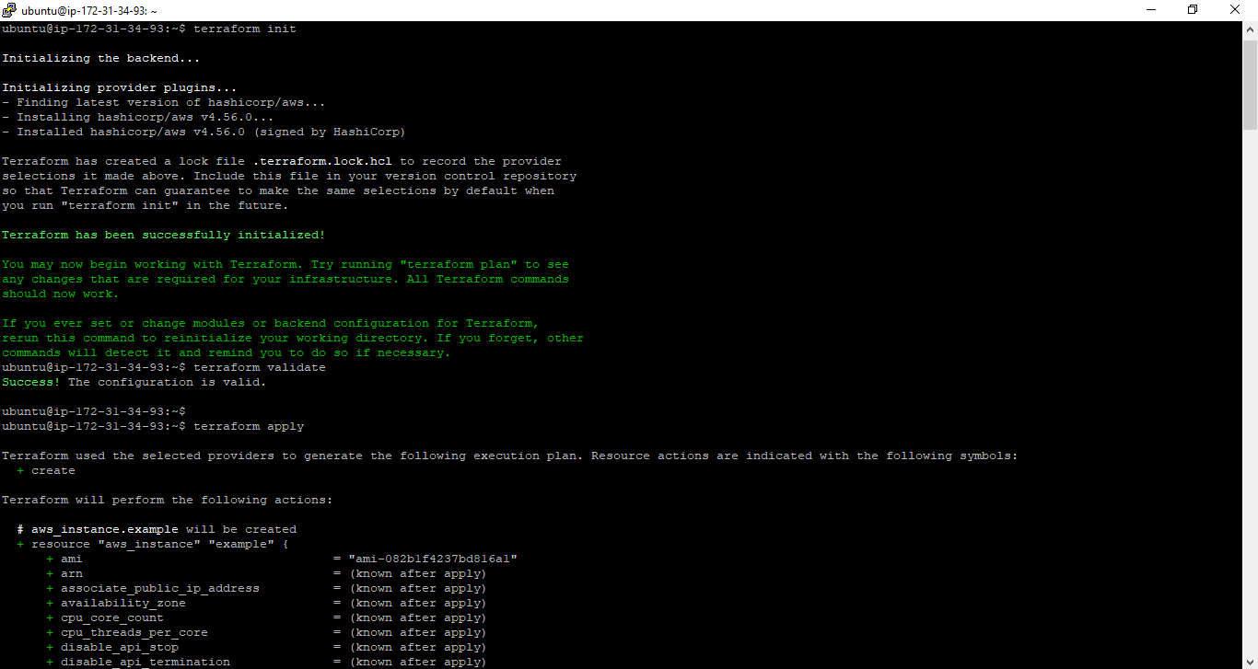

In this snap, we see that 2 EC2 instances are created.

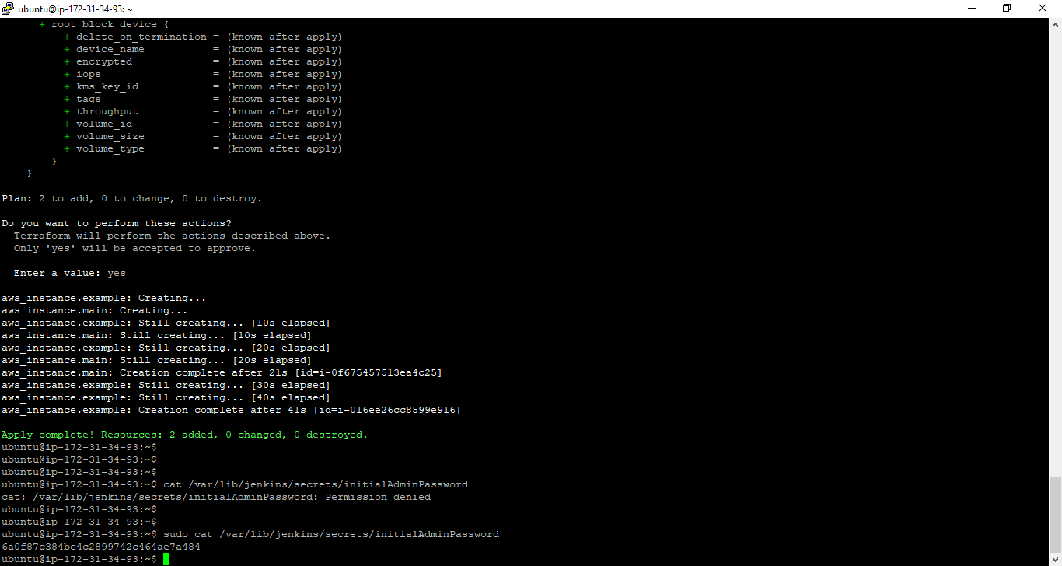

Initiating Kubernetes by command, ‘kubeadm init’.

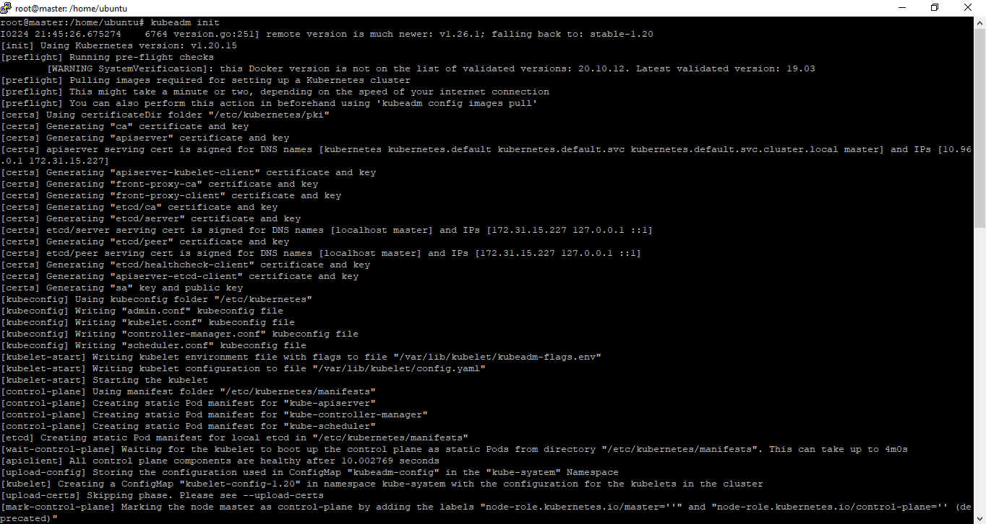

Making the directory, as well as following the given instruction by Kubernetes. We can see the nodes are available.

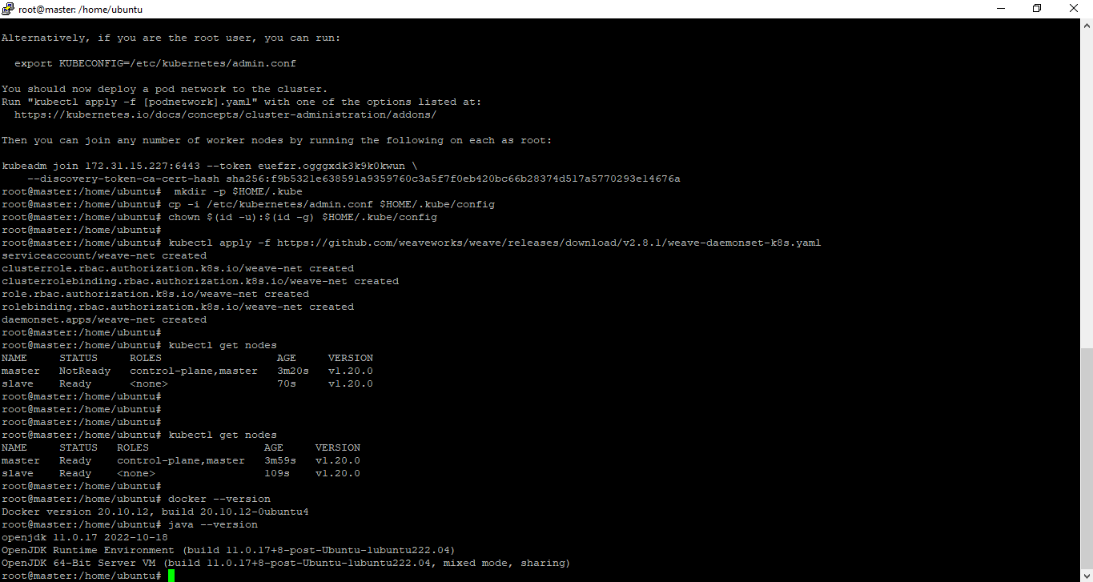

Slave node :

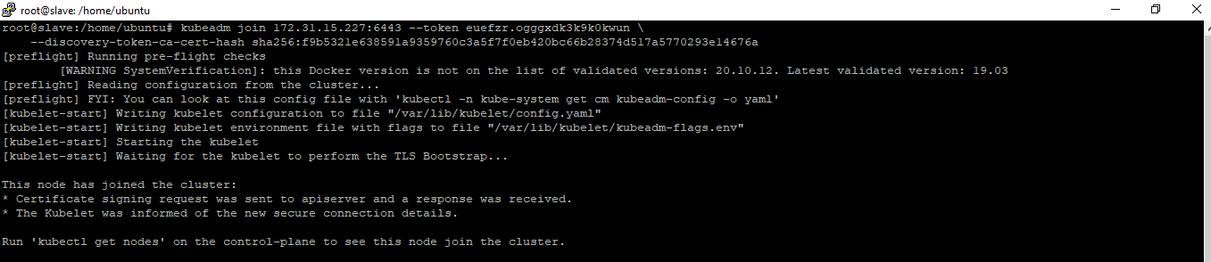

Creating ‘kub-master’ node :

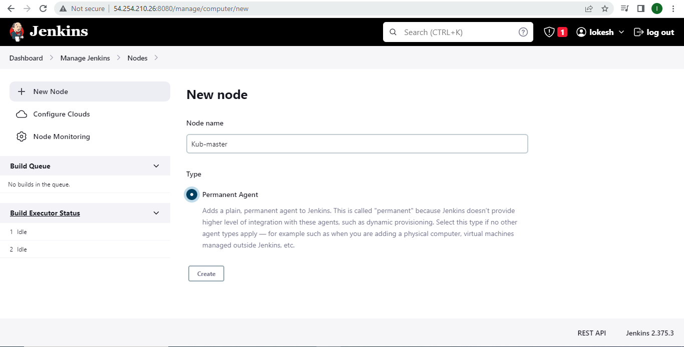

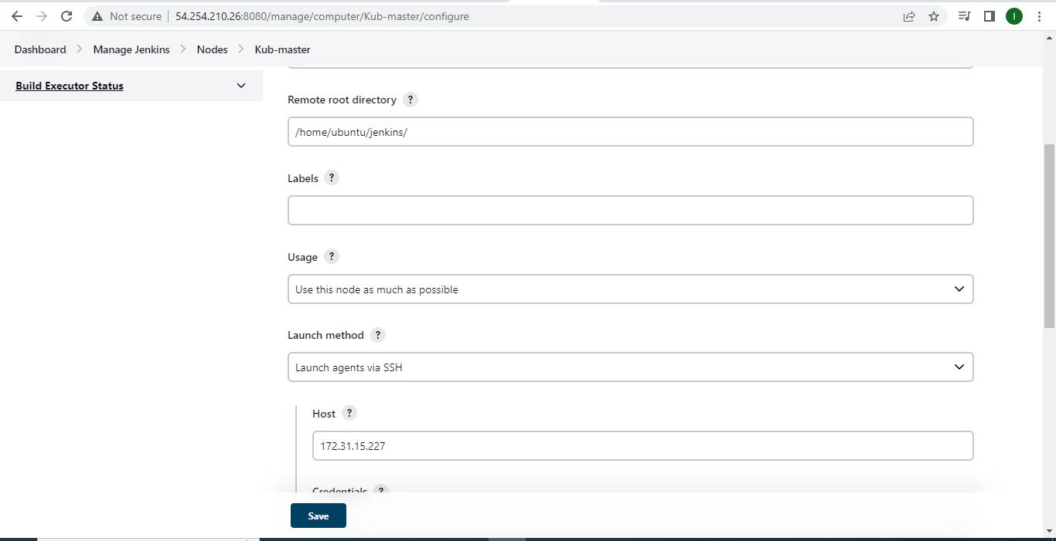

‘kub-master’ node is created :

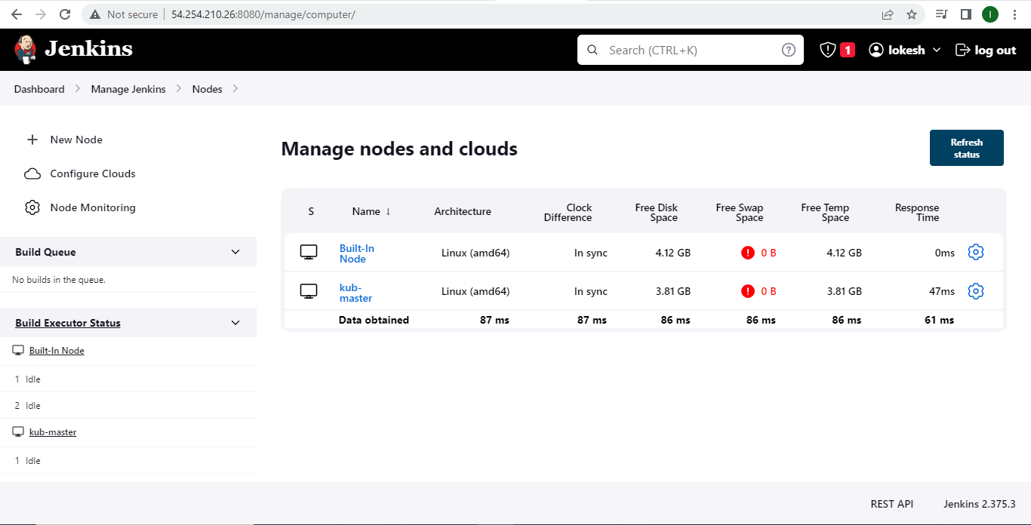

Creating Docker credentials for pipeline :

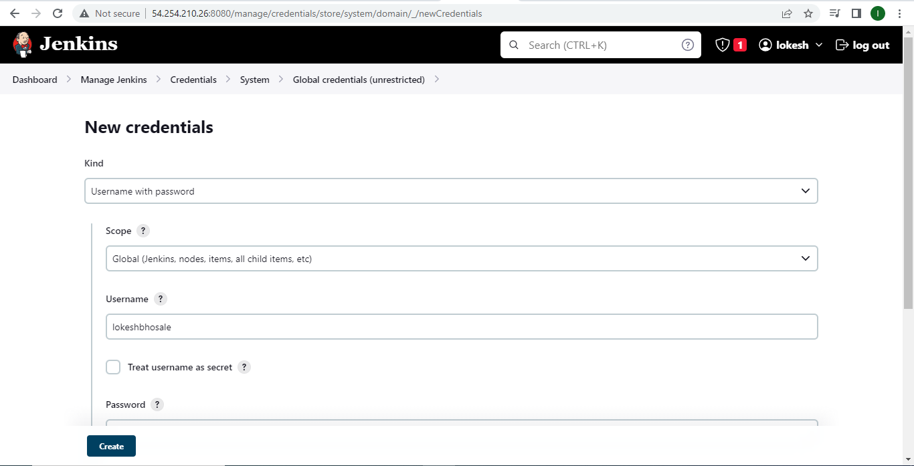

After creating credentials, we’ll get the credential ID which we’ll use in Jenkins script :

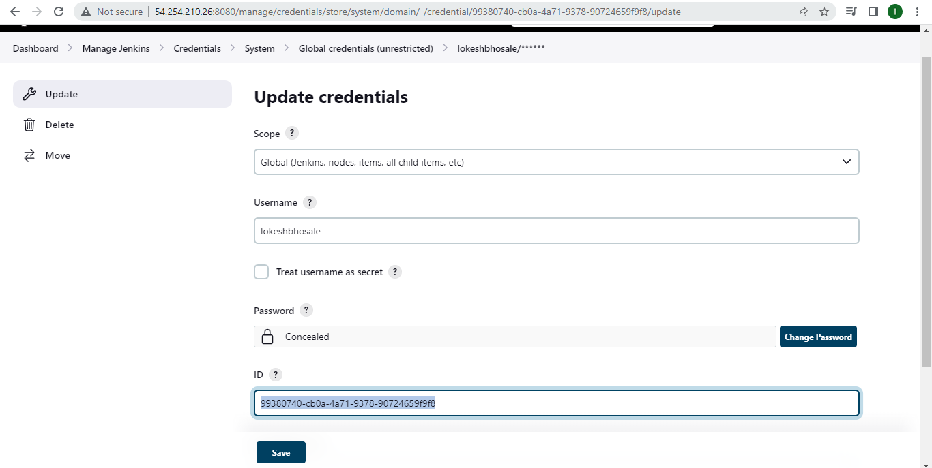

Creating pipeline named ‘pipeline’ :

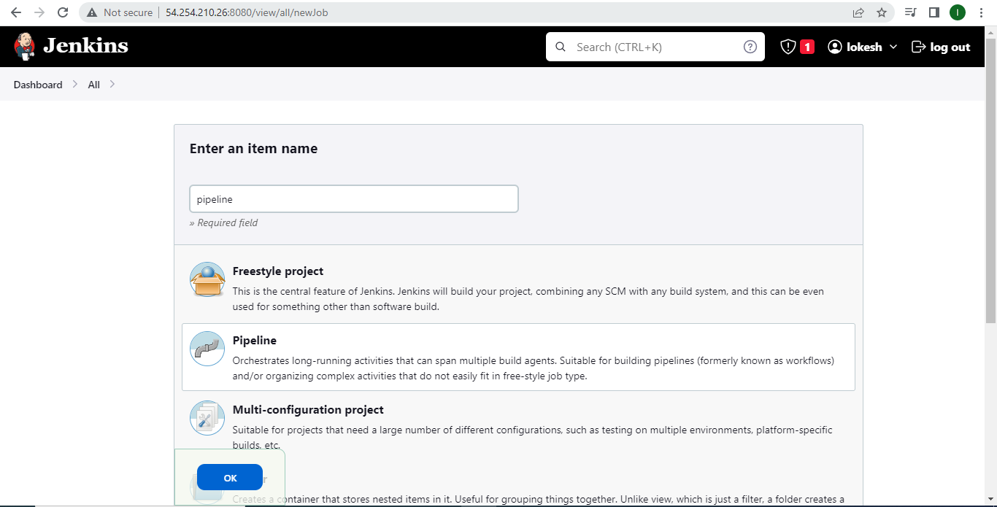

We’ll insert the pipeline script in pipeline script section :

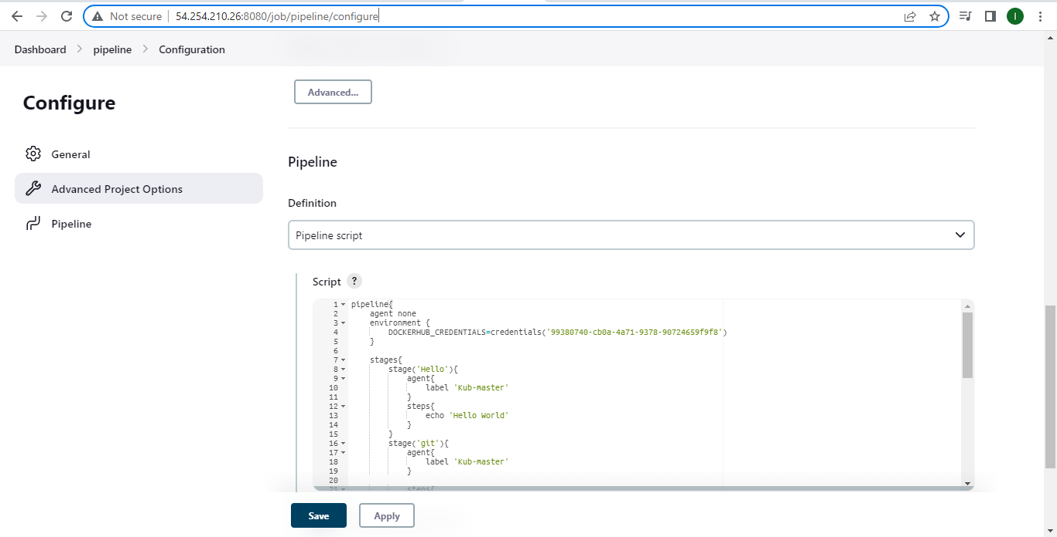

We can see that the pipeline is built successfully :

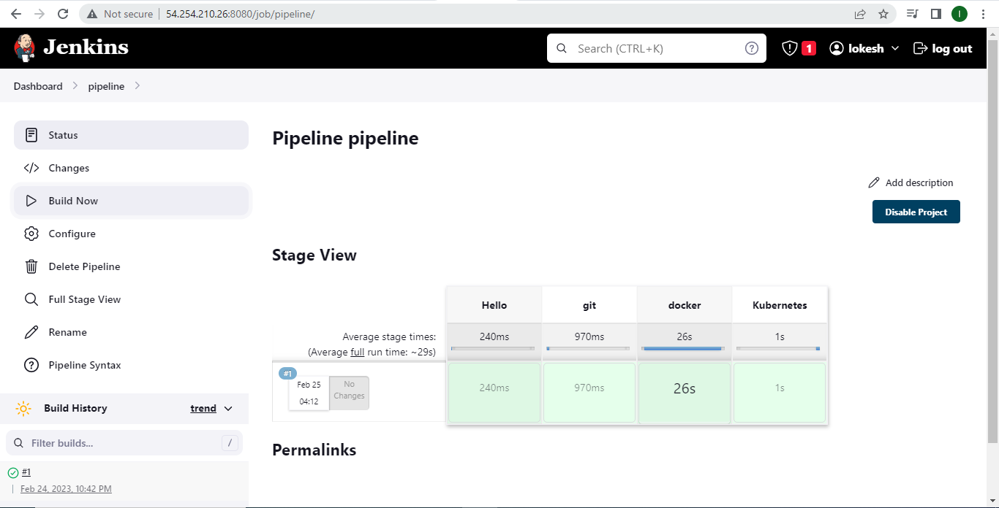

We can see the image is uploaded on Docker hub repository :

